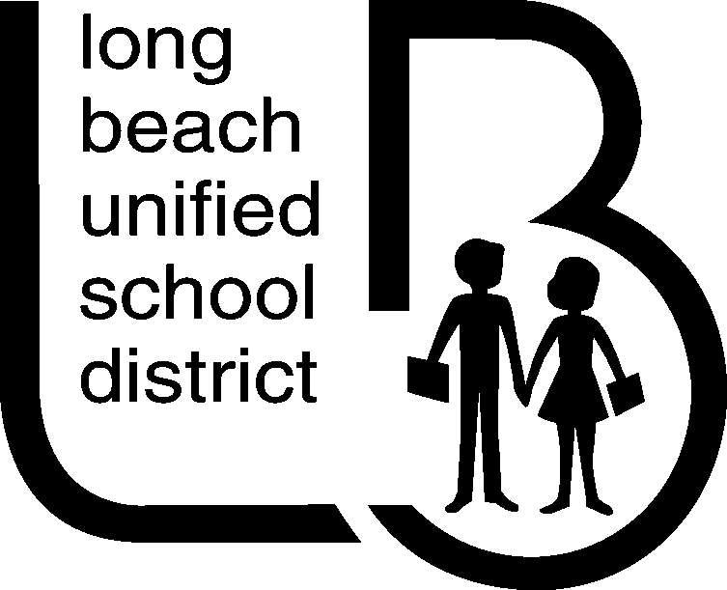OFFICE OF CURRICULUM, INSTRUCTION & PROFESSIONAL DEVELOPMENT
(562)997-8031 FAX (562)997-8293
pseki@lbschools.net

CREDIT FOR PRIVATE SCHOOL WORLD LANGUAGE STUDY

The granting of credit for world language studies successfully completed in a private school to students in grades 9 through 12 is authorized by state legislation (California Education Code, Section 51243 to 51245, and Administration Code, Title 5, Section 1632) if certain conditions and standards are met. The following procedures will be used in implementing this authorization in the Long Beach Unified School District:

- Maximum credit granted shall not exceed ten semester periods per year for work taken during the time the
student was enrolled and in attendance in grades 9 through 12 at a senior high school in the Long Beach Unified
School District. The minimum amount of credit sought shall be at least five semester periods.

2. The total amount of instructional time for which five semester periods of credit may be granted must be comparable to that of a one semester world language course offered by the Long Beach Unified School District;
instructional time for ten semester periods of credit must be comparable to a two semester course.

3. Student achievement in the world language must be demonstrated to be comparable to that which would be expected with the same or similar instruction at the specified level in the secondary schools of the district.

- The application form attached to this bulletin must be completed. It provides for the application for credit by the
student or parent or guardian in part 1, and counselor’s acknowledgment of student’s intention to apply for credit in part 2. In part 3 the private school principal verifies the dates and amount of instructional time, the language studied, and the student’s achievement based on results of a test developed cooperatively by the private school and the school district. The granting of credit is authorized in part 4. Upon approval by the school principal, the counselor will record the granting of credit on the student’s cumulative record and file the form in the student’s packet.

TO THE STUDENT:
1. Fill out part 1 of the application form on the reverse side of this bulletin.

2. Obtain in part 2 the signature of your counselor at the senior high school you are attending.

3. Return your application to the principal of your private school.

4. Take the world language examination for which you are eligible in your private school.

TO THE PRIVATE SCHOOL PRINCIPAL:
1. Issue a copy of this bulletin-application form as requested to eligible students attending your school.
(Request additional copies of this form, as needed, from Pamela Seki, Long Beach Unified School District).

2. Ask students to fill out part 1 of the application form and obtain the signature of the school counselor in part 2.

3. Consult with the school district about the cooperative development of final examinations to be given to students who are applying for high school credits.

4. Administer the world language examination for which the student is eligible.

5. Verify the student’s successful completion of the world language course by filling out completely all of part 3 of the application form. Sign the form and mail it to:
Pamela Seki, Director Office of Curriculum, Instruction and Professional Development 1515 Hughes Way, Long Beach, CA 90810
Publication Authorized:
Christine Dominguez, Deputy Superintendent
Curriculum, Instruction and Professional Development

