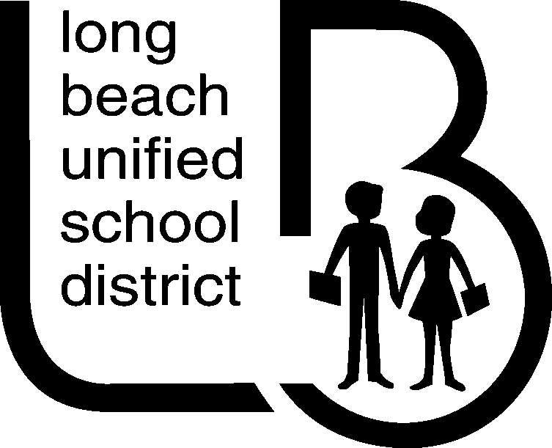Office of Curriculum, Instruction and Professional Development
World Language

1. APPLICATION FOR CREDIT FOR PRIVATE SCHOOL WORLD LANGUAGE INSTRUCTION (Student/Parent)

Student Name: |  | Birth Date:
Last First Middle Month Day Year

Address:
Street and Number City Zip Code
Home Telephone: |  | Parent’s Business Phone:

I hereby make application of ___________ Semester Periods of Credit in _____________________________________
(5-10) Language
Signed ____________________________________ ________________________________ ______________
Student Parent/Guardian Date
---------------------------------------------------------------------------------------------------------------------------------------
2. ACKNOWLEDGEMENT OF INTENTION TO APPLY FOR CREDIT, (LBUSD Counselor)

I acknowledge that the student named above, who is now attending ____________________________________ School, is currently enrolled in the ____________ grade and is making application for credit as indicated above.

Counselor’s Signature __________________________________________________ Date _______________________
(Counselor’s signature does not indicate approval nor disapproval of the request.)
---------------------------------------------------------------------------------------------------------------------------------------
3. VERIFICATION OF WORLD LANGUAGE INSTRUCTION (Private School Principal)

I certify that the above named student successfully completed the course of world language instruction, as described below, while concurrently enrolled in and attending grades 9 through 12 at a senior high school in the Long Beach Unified School District.
Language _______________________________________________ Total Hours of Instruction ___________________

Dates of Instruction: Beginning______________________ Ending_____________________
Month Day Year Month Day Year

Total Hours of Student Attendance _________________

Examination given ______________________________ Result____________________ Letter/Grade______________
Month Day Year (Passed/Failed)

Comments________________________________________________________________________________________

Name of Private School______________________________________________________________________________

School Address____________________________________________________________________________________
Street and Number City Zip Code

Telephone______________________________________________________

Signature of Principal_________________________________________________________ Date__________________
---------------------------------------------------------------------------------------------------------------------------------------
4. AUTHORIZATION OF CREDIT (LBUSD Curriculum Leader and LBUSD Principal)

I recommend that __________ Semester Period of Credit in ___________________________ to be granted to the above named student for private school world language instruction as described above.

Signed ________________________________________
Director, Curriculum
Approved by LBUSD Principal:
Signed ______________________________, Principal, _________________________________ School

